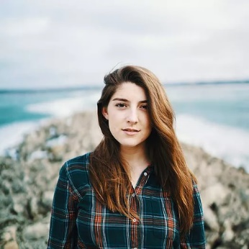

Education
Drake University; Des Moines, IA
- Bachelor of Arts in Journalism and Mass Communication, Magazines
- Bachelor of Arts in Writing
- Summa Cum Laude
- Honors Program participant

Relevant Skills
- Audacity
- Photoshop
- InDesign
- Google Trends
- Fact Checking
- Copy Editing
- Photography
- SEO knowledge
- Audio recording
- Interviewing sources
- Microsoft Office suite
- Familiar with SPJ standards
- Comfortable with AP Style

Get In Touch
- 224.688.2288
- angela.ufheil@gmail.com
- angelaufheil.com
Angela Ufheil
Editorial Experience
5280 – Associate Editor, October 2020–present
Assistant Editor, April 2018–October 2020
- Edit, write, and work with art team on monthly front-of-book section
- Spearhead environment, health, and social justice coverage with an eye on under-covered communities.
- Pitch, report, and write feature packages and narratives
- Drive traffic to 5280.com with investigative articles and issue analysis

Freelance – Midwest Living and custom publications, April 2018–present
- Write product round-ups and health pieces for Midwest Living
- Research and craft travel stories for Pure Michigan and Enjoy Illinois

Midwest Living – Editorial Assistant, Summer 2015–April 2018
- Researched, interviewed sources, and wrote stories for print and online
- Reformatted and uploaded print stories to website
- Fact checked magazine and travel guides

Des Moines Register – Breaking News Intern, August 2017–February 2018
- Reported breaking news with articles and video
- Interviewed sources to add human element to crime stories
- Copy-edited articles and scheduled social media posts

Allrecipes Magazine – Meredith Apprentice, Fall 2016–Summer 2017
- Pitched and wrote stories for each issue
- Calculated and analyzed photoshoot and issue budgets

Urban Plains – Squad Leader and Editor, Spring 2017
- Researched and wrote articles that drove site traffic
- Conducted interviews, wrote scripts, and hosted podcast

Drake Magazine – Managing Editor and Writer, 2014–2016
- Helped writers produce intriguing, cohesive stories
- Researched and wrote feature pieces and several shorter articles

Honors & Activities
- National City & Regional Magazine Awards, Best Magazine Section
Winner, 2020
- AEJMC Student Magazine Contest, Best New Magazine Idea, 2017
- Richard Tapscott Reporting Award, 2017
- Thomas Dunn English Scholarship Award, 2016

